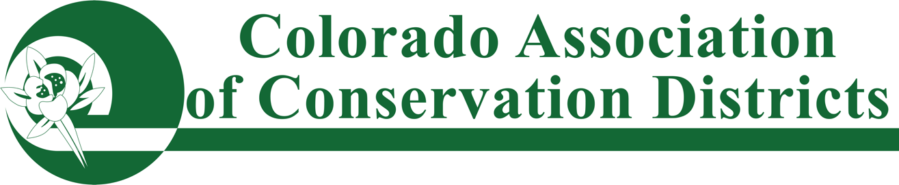

CACD Award Nomination Form

Award Categories:
- District of the Year
- Supervisor of the Year
- Conservationist of the Year
- Educator of the Year
- Education Program of the Year
- CACD Hall of Fame

Nomination Process
Please complete the attached nomination form & submit it to your watershed for voting. Please check with your watershed for their deadline date.

Nominations should include a description (1000 words or less) of how your nominee has excelled within the area they are nominated for. Letter(s) of recommendation from partner agencies and/or agricultural affiliates may be included. Please also submit up to five (5) pictures as attachments to the form, not in the word document.

Once the winner has been chosen by your watershed, the nominating district will need to submit this nomination form (word doc), along with supporting letters & pictures to CACD via email at cacd@coloradoacd.org no later than October 15th.

JUDGING & AWARDS:
Entries will be judged by the CACD Awards Committee. Once a winner is chosen by CACD; The nominating district may be asked to provide clarification, additional photos, or other information for recognition purposes. The winner will be recognized at the CACD Annual Meeting and an invite for the winner plus one guest will be extended via the nominating district.

CONSERVATION AWARDS NOMINATION FORM
Nomination for
Individual, Program, or District Name:
Farm/Ranch/Operation Name (if applicable):
City/Town:
Conservation District:
Telephone:
Email:
*********************************************************************************

Nominating Conservation District:
Point of Contact (District Manager or Officer):
District Phone:
Email:

Supporting letters of recommendation may be in PDF format.
Pictures submitted MUST be in JPG or PNG FORMAT:

All nominations passed by a watershed must be submitted via email at cacd@coloradoacd.org

***

Nomination Narrative

